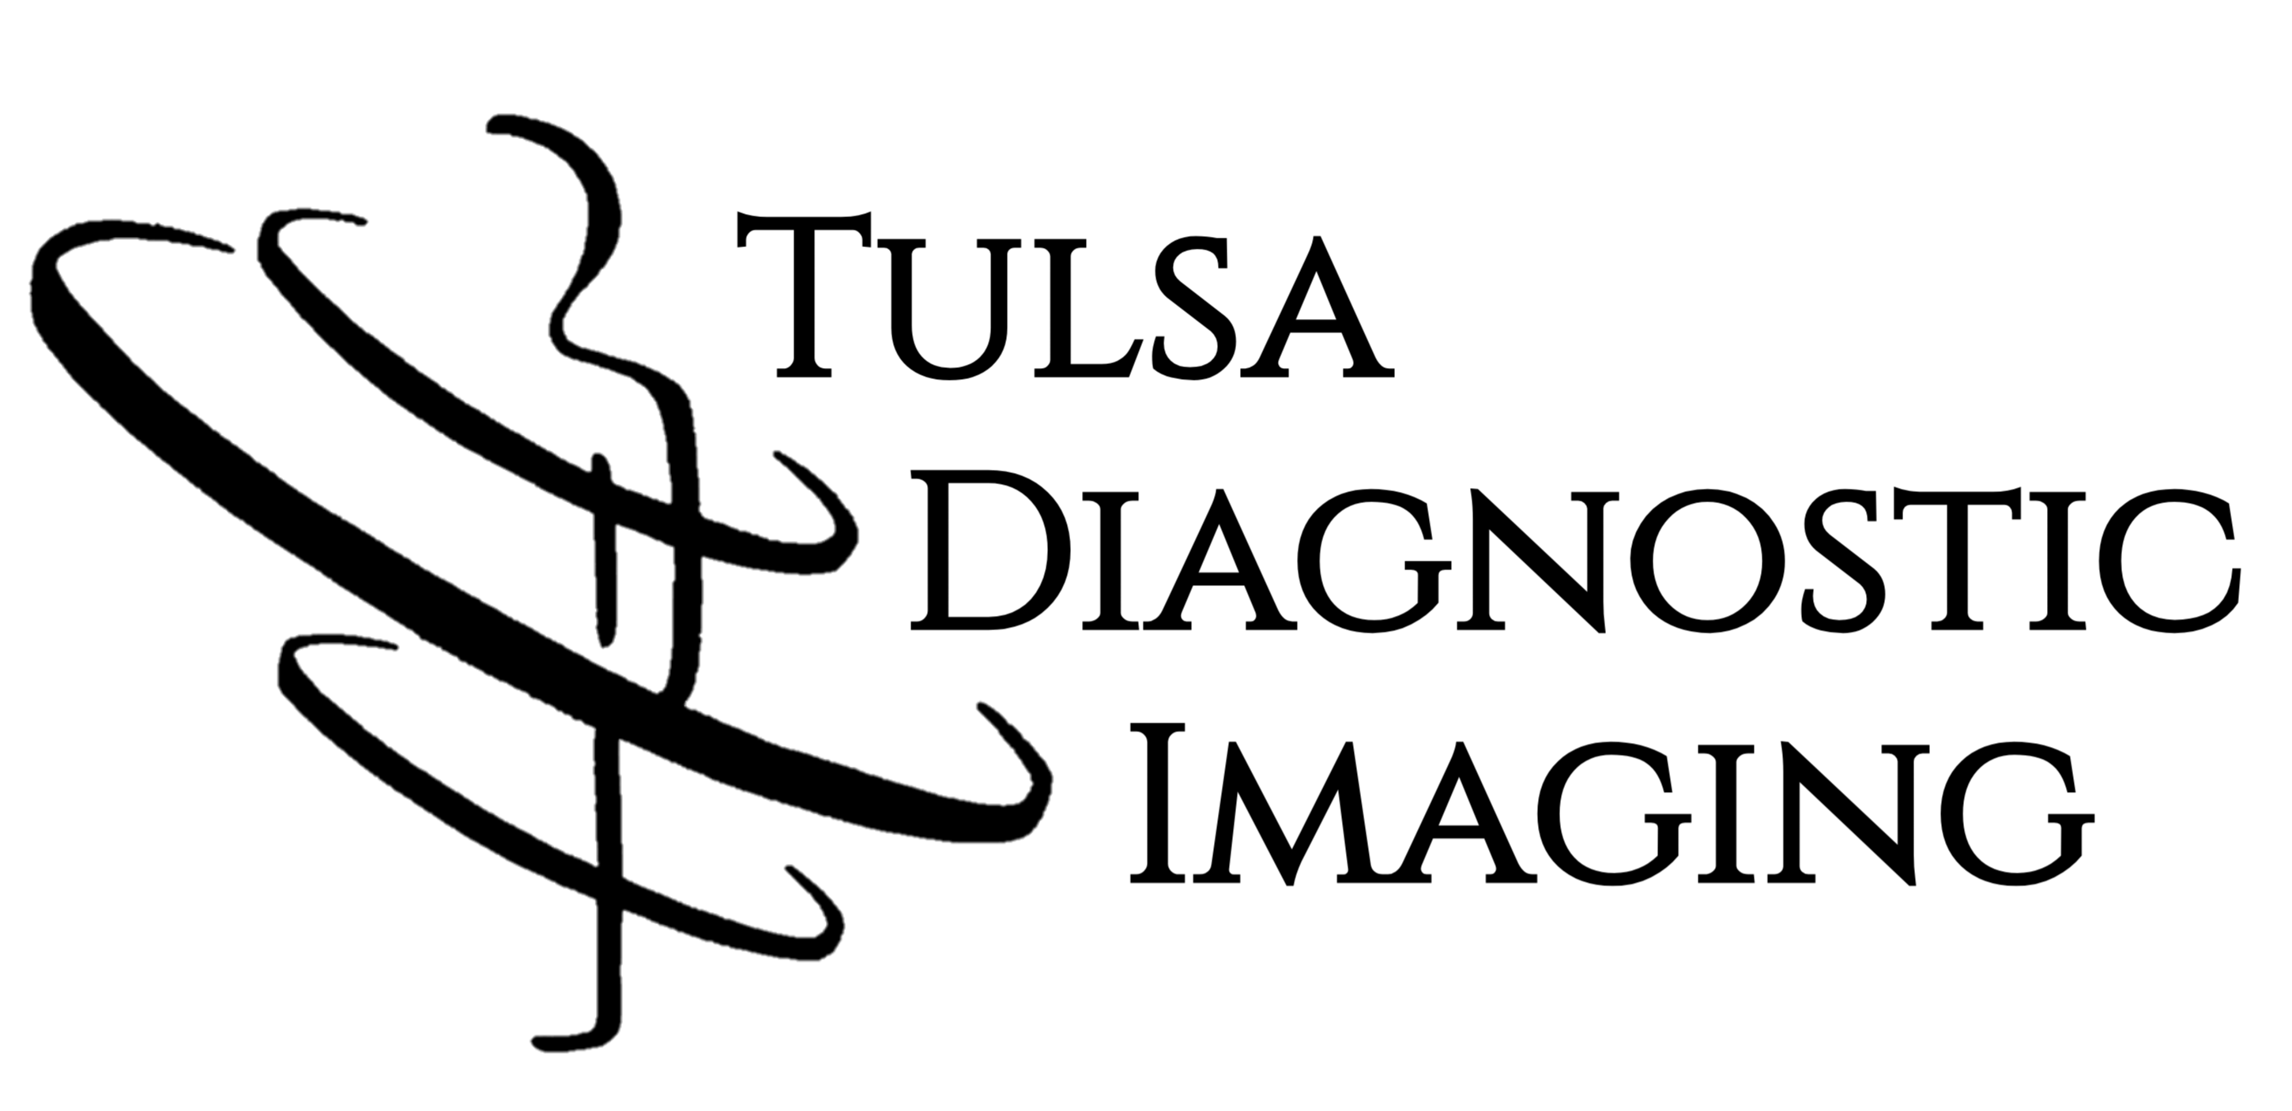

6046 S Sheridan Rd, Tulsa, OK 74145 | P: 918.499.1674 F: 918.499.1675

□ Personal Injury □ Workers Comp □ Health Insurance

Patient Name: Phone:

Date of Birth: Patient Height: Weight:

Referring Provider: Phone:

MRI(s) Requested: Fax:

Diagnoses:

Any previous surgery on this region? □ Yes □ No If so what kind?
Are there any metals or programmable devices in patient’s body? □ Yes □ No
Has patient ever had metal particles in their eyes? □ Yes □ No

Provider Signature: Date:

Serving Green Country with Superior Imaging & Devoted Care Since 2004

